DRNACH INTERNATIONAL INC
2021 ANNUAL REPORT
The pandemic continued to highlight hardships for many of us here and across the globe. From social distancing, sanitizing, creative learning and vaccine rollouts, our
partners continued to show flexibility to meet the needs of their communities. In our third year, we continued to work closely with our partners to provide monetary
support to achieve their intended activities.

Your donations supported many aspects of a child's learning experience. In Jukwa, Ghana, donations continue to support teacher salaries as they navigate the world of hybrid learning and offset student's tuition payments, which allowed children to
continue to learn to become leaders of the future. In Merida, Mexico, donations
allowed for the continuation of educational and therapy services to children during a time where funding threatened their availability.

We are fortunate to have a personal relationship with the individuals who run the
programs you support. We assure you that 100% of your donation is used directly to benefit overall well-being and education as the community sees fit. While 2021 was a challenging year for many, together we alleviated hardships.

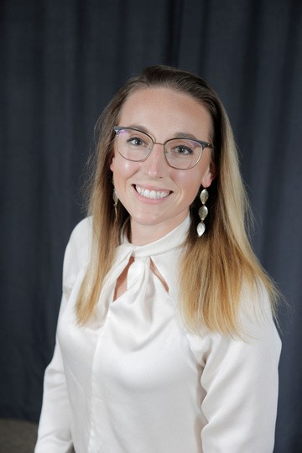
Mission: To support the education and well-being of children and families in developing countries

Vision: All persons have an equal opportunity to a basic education and health services.

Established January 16, 2019

Grace Drnach-Bonaventura
Board Members
President- Grace Drnach Vice President- Amanda Sparico
Treasurer- Mark Drnach Secretary- Danny Bonaventura

2 0 2 1 A N N U A L R E P O R T

FINANCIAL REPORT 2021

Total Raised

$2,323.37
Total Donated

$2,545

Individual Donors
Individual donors were the main source of funding in 2021.

Masks and Giving Tuesday
Through the generosity of volunteers who sewed masks, DI continued to raise donations through distributing masks and contributions through Giving Tuesday.

Other
Other donations include Facebook Birthday campaigns and donations from AmazonSmile.

2021 Donations Disbursements

This past year, Drnach International distributed $2,400

Jukwa, Ghana Merida, Mexico
International Wiring Fees

0 500 1,000 1,500

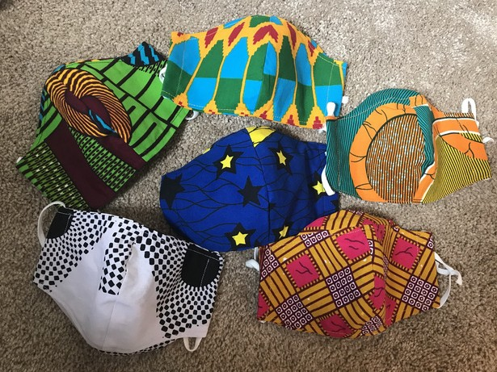
It is important to us that our partners spend the donation as they see best fit for the well-being of their communities. DI covers the cost of international wiring fees, and ensures the donations arrive to our respected partners.

2 0 2 1 A N N U A L R E P O R T

DIVINE KIDS ACADEMY
A MESSAGE FROM THE FOUNDER

During the height of the pandemic, Ghanaian schools were closed down by the government for 10 months to reduce the spread of COVID-19. There were changes when schools resumed. Schools changed from trimester (three terms in an academic year) to semester calendars by the government.

DKA also experienced changes as schools reopened:
Out of a total of 15 pre-pandemic staff members (teaching -13 and non-teaching -2), only 3 teaching staff returned to the school.
New staff members were employed in the first week of reopening and one of the more experienced staff members was appointed the head of academics.
Thanks to a thorough orientation, the staff members blended easily.
DKA had our first teachers’ social outing in July 1st at the Heritage Beach. It was great.

The school has approximately 350 students, 11 teachers, and 4 non- teaching staff.

Students take classes such as English, French, Music, Science, Math, Computer Literacy, and Physical Education.

DKA organized an academic training program for all the teachers
in 6th August.
The first meeting for the 10th Anniversary Program was held in November 2021.

Student Achievements in 2021:
Reading and spelling greatly improved due to the formation of
Language Club in the school.
Weekly mathematics exams were introduced, improving the standard in mathematics.
The students at DKA had the first Christmas Carol Service on 11th December to close the academic year.

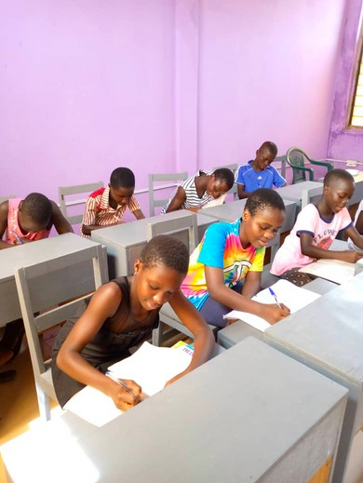
DKA received support from DI International in 2021. From that support (approximately):
Canteen (Food) Supplement- $700 School Maintenance - $150 Teacher/staff salary for 6 months - $460

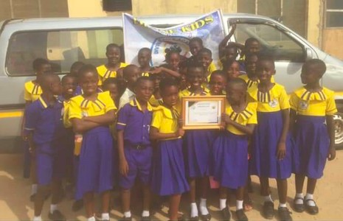
-Written by: Kwame Appiah-Kubi, Founder of Divine Kids Academy
One student's tuition costs $36 for the year, which is the main source for teacher salaries.

DI aims to support all students regardless of financial means and supports equal and fair pay to teachers.

2 0 2 1 A N N U A L R E P O R T

2021 PARTNERS

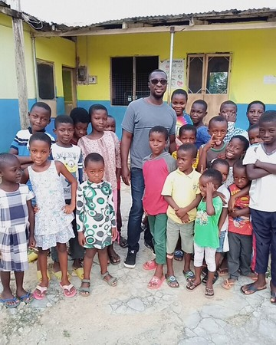
DIVINE KIDS ACADEMY, JUKWA GHANA
Founded by Patrick Appiah-Kubi "Kwame"(middle adult in photo), Divine Kids Academy (DKA) was established to give
children a firm foundation for a quality education. DKA strives to continue to operate so no child is denied an education, or a lunch, due to lack of finances.

DKA celebrated its 9th year and serves over 350 students.
This year, the DKA team and DI are partnering to celebrate the upcoming 10 year anniversary of the school in 2022.

SOL Y LUNA AND ASOCIACION CONSTRUYENDO SONRISAS, MERIDA, MEXICO
Sol y Luna is a nonprofit social assistance project for boys and girls with intellectual disabilities from low-income families. This project provides an environment for social assistance, health, and nutrition and accommodates parents who have a working
schedule. The Asociación Construyendo Sonrisas raises the quality of life for persons with motor and/or mental disabilities through comprehensive and personalized
programs of physical and educational therapies.

UPCOMGING EVENTS
Divine Kids Academic will be celebrating their 10th Anniversary in October 2022. DI, DKA, and friends of DKA are working together to organize a virtual celebration to highlight student and teacher success, support future initiatives, and honor
the commitment of the school. Check our social media pages for more details throughout the year.

We will continue our fundraising efforts throughout 2022 to continue to support our partners. Donations can be made directly on our website, through PayPal,
Facebook, or Venmo (@Drnach). Donations can also be mailed to Drnach International 2224 Parklyn Street, Pittsburgh PA 15234.

